

Wood Technology Group Winter 2024 Newsletter
Welcome to the latest Wood Technology Group (WTG) newsletter. After a lull in producing the newsletter, we hope to be back on track this year. So, this will be a bumper crop of news to include material from 2022 and 2023 that seemed too good not to share.
2023 has also been a busy year for the sector more widely - there is great interest in the benefits of timber and wood products. The focus on timber as a low carbon material, and a part of the route to net zero is set to lead to further research, policy and growth in the industry in 2024.
Here is a short update from the WTG, we have now recruited some new faces to the leadership group and can look forward to new project starting - more on these in the next issue.
- Morwenna Spear FIMMM

Timber 2023
I'm just back from our Timber 2023 event - and enthused by all the interesting presentations and discussions that it generated. The conference was run as a winter conference this year, and the one­ day format allowed eleven high quality talks, with plenty of opportunity for questions and discussion in the auditorium.
Most interesting to me was the mix of topics - with the first session looking at aspects of timber in construction, through the eyes of architects and farm-scale system based on sweet chestnut coppice. We also learnt of a large body of work under the banner 'Transforming Timber' in the project of the same name at Edinburgh Napier University. Then we had a very entertaining glimpse into the life of a timber consultant - reusing original timbers in the restoration of Smithfield Market in London.
After lunch we settled down for a cluster of wood science talks, featuring several new faces. These ranged from the physics behind calculating the transfer of heat in a nail during combustion of a wooden element through to the chemistry of changes that happen when strip barking pine trees to enhance durability or longevity by natural methods in northern pine forests. The physics moved from theoretical to practical with an introduction to many ways that CT scanning can be used to study wood and finally learnt the intricacies of measuring water in its different states of association with the wood cell wall using DSC.
To round off the event we heard from Callum Hill about the challenges of generating a carbon footprint for a sawmill - and the need for good quality data. We then picked up on the Building from England's Woodlands project looking at markets and opportunities for homegrown timber. Finally, we had insights into the moisture dynamics within the CLT and glulam building that houses the timber department at NMITE in Hereford.

Naked clams - the new name for Teredo shipworm
A study at Plymouth University has been farming shipworm, in a pioneering project to generate protein rich food for the future from sustainable aquaculture. Apparently, the naked clams are also rich in Vitamin B12, with double the quantity obtained from blue mussels. The story recently featured on the BBC news.
Always one to innovate, Gervais Sawyer has been involved in the project, assisting with the development of a feeding apparatus based on different close-packed wood to allow the clams to be easily removed for analysis or harvesting. He commented:
‘The project is all about breeding Teredo shipworm. This is a bivalve mollusc very like a mussel. It is a plankton feeder, filtering seawater, but its shells have become adapted as tunnelling cutters. As they bore into wood thy line their tunnels with calcite. When Mark Brunel saw a bit of wood affected like this it gave him the idea for the tunnelling shield and lining for the Thames tunnel. (It didn't give him the idea for naming his son lsambard!)
The problem with breeding Teredo is that one, you can't see how big they have grown and two, how do you get the animals out without killing or damaging them.
The answer to one is easy. The calcite tunnel lining is X-ray opaque so you can easily image that.
The answer to two, is more difficult. So, what we have evolved is a range of feeding apparatus. The first is to build a pack of 1mm thick sawn pine veneers that are clamped between two sheets of Perspex plastic. Easy to X-ray. When big enough you just peel away each veneer, one at a time until the animals are revealed. Of course, they will be in their calcite tubes but a light crushing, and wash removes that. The second apparatus has packs of 3mm x 3mm sticks that are tightly clamped in square tube. Again, proceed as above. It all must be close clamped because they can detect gaps and will turn away. The third apparatus uses bars of compressed sawdust/woodchip (no waste from producing the veneers and sticks!) packed into pipes.
The Australian aborigines cultivate these in palm tree logs, but their tropical shipworms grow MUCH BIGGER. Yum, yum - bush tucker!! Not for me thanks.’

What’s coming up in 2024?
Also watch out for a new series on our X/Twitter account (@wood technology) during the spring. Under the working title 'Members Tools' the game will be to guess the tool, product or equipment based on a visual clue posted in the morning. There will be time to interact and post your guesses during the day prior to the answer
being revealed later. All items will be wood-related or used by those working with wood in a few ways - whether in research, consultancy or industrial applications. Should be great fun!
We recently recruited some new faces to the WTG leadership group and are looking forward to being able to start new projects and activities. The current leadership group is: Morwenna Spear (chair), Dennis Jones (secretary), Graham Ormondroyd (past chair), Martin Ansell (Talking Timber coordinator), Andrew True (website), Laura Keily (web assistant), Gervais Sawyer (IWPJ Editor), Tim Belden (social media), lain Thew, Jim Coulson, Andrew Gibson, Adrian Hall, Tabitha Binding, Daniel Ridley-Ellis. Our technical community is also supported by Hannah Lord from the IOM3 team. If you have ideas of what you would like to see your technical community do for you, do feel free to get in touch - between us we cover many areas from education and training to a range of products, companies and consultancies.

WTG people - Andrew True reports

 |  | It is a pleasure to announce that Dr Morwenna Spear has been appointed the new Chair of the Wood Technology Group, succeeding Graham Ormondroyd (see below).  Morwenna brings to this four-year term of office a wealth and depth of wood science and industry experience.  Morwenna is a Research Fellow at The BioComposites Centre, Bangor University. For more on Morwenna please visit the WTG webpage.
It is also a pleasure to announce that our previous Chair Prof Graham Ormondroyd has been appointed Vice President of IOM3, in preparation for eventually being president of the Institute. He also acts as strategic advisor for the IOM3, interacting with several technical groups, including the Natural Materials Group, the Construction Materials Group and the British Composites Society.
Graham will continue to sit on the WTG board.
Gervais Sawyer, honorary editor of International Wood Products Journal (IWPJ), has now received over 600 submissions for publication. Gervais says, ‘I don't know if I am pleased or exhausted!’
Gervais has edited submissions from more than 28 Countries and covering many aspects of wood science and technology. Submission number one was on 1 June 2010 and was rejected by Gervais for publishing.
There are four publications per year, and over 375 Reviewers.
The most popular paper submitted was by Dr Callum Hill FIMMM.
 |  | John Park has retired after SO years membership of the Institute of Wood Science, the Wood Technology Society and the Wood Technology Group, including being a Board member for over 30 years.  John is a past Chair of IOM3's Wood Technology Society, and in earlier times was Chair of the London Branch of the IWSc.  John has been instrumental in establishing our regular and diverse TTJ series ‘Talking Timber’. Since its inception in 2016 he has edited 61 articles, of which he has written 21 topical, thought provoking, and often humorous pieces.  An expert in ‘rules and regulations’ his input has helped shape many of today's official Standards - both UK and EU. He is a well-known figure in the trade, and a regular attendee at various timber trade clubs and functions.  John plays the guitar and is now looking forward to learning the lute, getting to grips with watercolour, getting back to piano, getting down his golf handicap and getting up his model airplanes!  We wish John a long and happy retirement!


Significant industry perspectives
2023 saw two important publications by the timber sector. The first was the launch of the Timber Industry Net Zero Roadmap, launched by TDUK in January 2023. This document was the result of collaboration between TDUK, CONFOR, BWF, TOCA, WPA, WBPI, ASBP, STA, Timcon, WRA, and NMBS. The roadmap analysed the current carbon emissions associated with industry activity and identified steps for decarbonisation over the coming years. Importantly, the sector is already in a relatively good position, and progress to decarbonise energy in the UK economy will further reduce our carbon footprint. However, the report makes interesting reading and highlights extra steps that can be taken.
The second notable publication is the Timber in Construction Roadmap, which was launched just before the end of 2023. Published by DEFRA, it applies to England, but sits in the wider UK context, where timber in construction is already seen as an important part of the net zero agenda for Scotland and Wales.
The Timber in Construction roadmap identifies priority themes, including improving data, promoting the safe, sustainable use of timber in construction, increasing skills, capacity and competency across the supply chain, and increasing the sustainable supply of timber. Other priority themes are addressing fire safety and durability to safely expand the use of mass timber, and increasing collaboration with insurers, lenders and warranty providers. There is also a priority to promote innovation and high performing construction systems. Many of these themes match issues which have been aired in the WTG, either in our webinars or at the conferences over the past few years. We look forward to continuing to engage and seek progress for our industry.
Take a look at the timber in construction roadmap.

International Wood Products Journal update
The International Wood Products Journal (our flagship publication) has just been awarded an Impact Factor (IF) of 1.1. This is a very respectable ranking for journals in the field of wood technology. For those in academia, the IF ranking will be a familiar consideration when selecting journals for publishing your work. For those in industry, lets simply take this as a recognition that the journal gets read, and the articles get cited - a sign that we are successfully disseminating wood science knowledge.
Why not take a look? We recently moved our journal publications form Taylor & Francis to Sage Publications and the International Wood Products Journal can be accessed on Sage, or through your IOM3 login. It is a significant member benefit - along with many of the scientific journals from Sage which can be accessed for free.
Schools event - inspiring the next generation
Gervais Sawyer had a new assistant for his stand at the Harrogate careers fair this year, and Nigel Thompson got into the part as policeman for the wood detective game. The event aims to promote science to primary school kids.
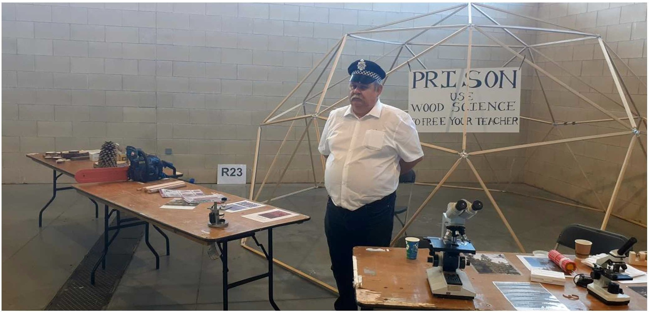
In the interactive challenge, the children get to use wood science to identify the wood used in a 'crime' and free their teacher from 'prison'. A range of exhibits are investigated to solve the crime, with plenty of hand on activities. This year was Nigel's first as assistant, Gervais commented that, ‘he was perfect for the part and very good company’.
Very small wood transformed to giant street art project

A large installation in a Bristol shopping area has featured wood microstructure! Gervais Sawyer was just one of the microscopists and wood anatomists who submitted images to the project for selection and use. Commenting about the project, Gervais said, ‘The beauty of wood never ceases to amaze’.
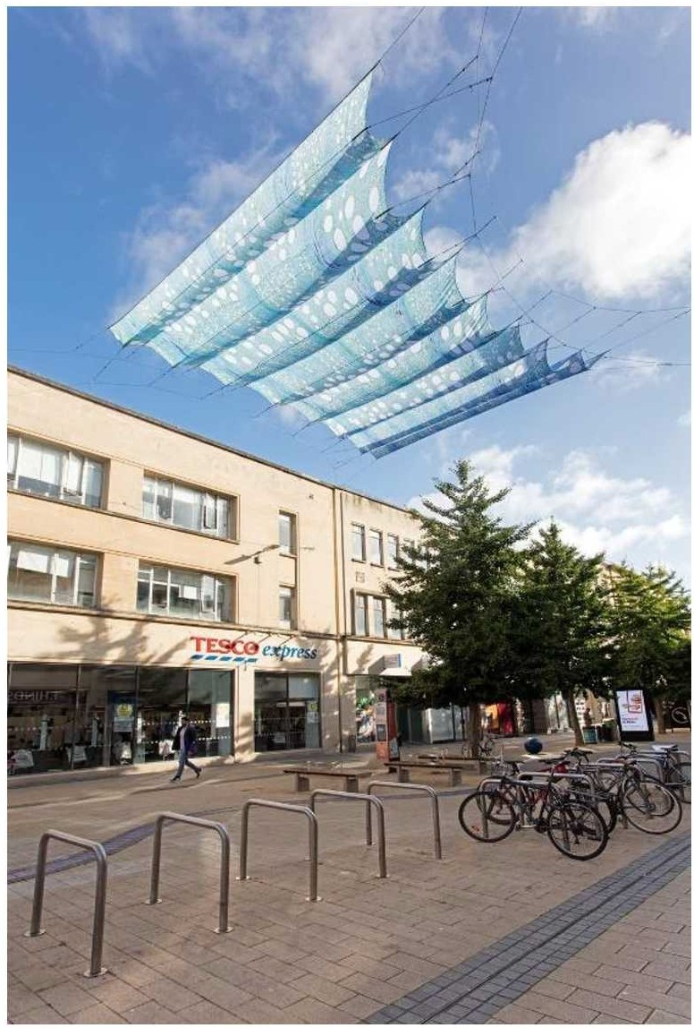
Entitled 'Overstorey' the installation was funded by the Public Art Commission and delivered by artists Ivan Morrison and Heather Peak. Between 19th and 30th August 2022, shoppers were able to enjoy large wood micrographs suspended overhead in the street. Full write up is available from the project's web page.
OVERSTORY was produced by PONY and commissioned with The Natural History Consortium, delivered as one of the activities under the City Centre and High Streets Recovery and Renewal programme, funded by Bristol City Council and the West of England Combined Authority's Love Our High Streets project.
The Natural History Consortium is a charitable collaboration of 14 organisations (including Avon Wildlife Trust, Bath & North East Somerset Council, BBC, Bristol City Council, Forestry England, Bristol Zoo Gardens, Department for Environment, Food and Rural Affairs, National Trust, Natural England, University of Bath, University of Bristol, University of the West of England, Wildfowl and Wetlands Trust, Woodland Trust) working together on a shared mission: to develop, test and disseminate best practice to engage everyone with the environment and natural world.

Social Media
Remember to keep an eye on our social media accounts!
We have an X account (@wood technology), lnstagram (@wood technology society) and Linkedln.

What's coming up soon?
If you have received this newsletter then you will have the WTG selected as your technical community (or one of your technical communities) in your IOM3 membership login. This will mean you also receive direct emails from the IOM3 events team about upcoming webinars or activities that feature or relate to wood. A lot of the other technical communities and interest groups interact with the WTG, for example sustainable materials, construction materials, packaging and natural materials. I do hope you will take advantage of these opportunities to interact in the IOM3 community in the wider sense.
On our website on the Wood Technology Group page, you will notice there is an events segment part way down the page featuring WTG and related activities.

