

COMPOSITES TECHNOLOGY DIGEST

ISSUE 1: WINTER 2025

Authored by The IOM3 Composites Technology Working Group* on behalf of the IOM3 Composites Leadership Team
*Guest authors highlighted in relevant articles

Contents

- Research & Development News
- Project Focus - MAXBlade and CoTide
- Materials Metrology Technology Focus
- Funding Opportunities

- RESEARCH AND DEVELOPMENT NEWS

Bio-inspired optimisation of composite fibre lay-ups for improved performance

Recent academic research has led to an innovative laminate design technique based on observations from naturally occurring composites. Unconventional laminate lay-ups are deployed to minimise the degree of anisotropy and thus deliver improved mechanical properties and damage resistance.

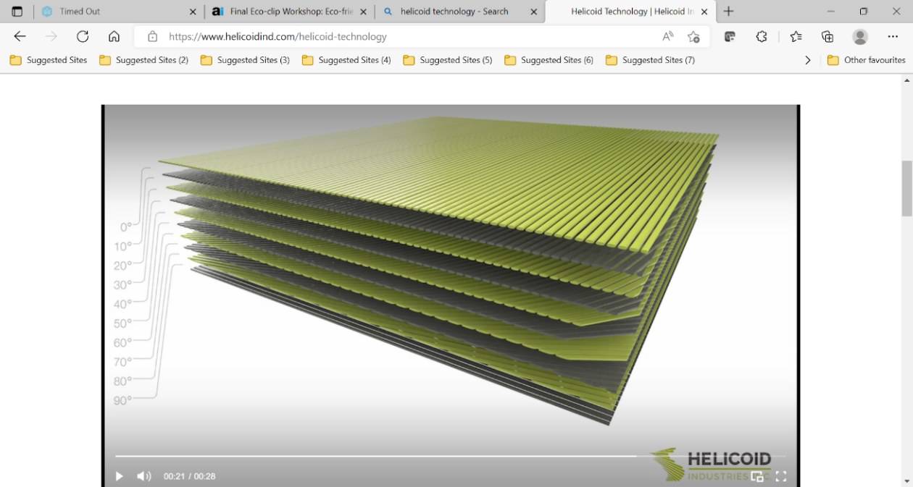

An example of a shallow angle multi-directional laminate (Ref: www.helicoidind.com)

Helicoid Industries (Indio, California) have developed a patent protected laminate lay-up design technique that promises notable improvements in mechanical performance of fibre composites. The technique mimics aspects of natural composites where lamina are stacked with low pitch angle between the neighbouring plies. Such fibrous structure has been most notably observed within the smasher claws of the Mantis Shrimp, which are used to attach its hard-shelled prey. The remarkable damage resistance of the claws has been attributed to their fibrous composites’ microstructure. The resulting helicoidal stacking sequence can minimise the mismatch in directional properties of the neighbouring plies, thus reducing the propensity for delamination growths. In contrast with more conventional lay-ups, interlaminar and through-thickness damage progression is reported to be notably reduced. Other benefits include 50% improvement in impact strength and 20% increase in residual compression strength after impact.

The company services provide simulations to optimise laminate designs for specific applications. They also offer customised non-crimp fabrics and dry/prepreg preforms, whilst the approach is particularly well suited to exploitation by automated fibre placement (AFP) processing equipment.
Applications requiring high damage tolerance & resistance to indentation/through thickness penetration are likely to benefit most. However, as composite designers know, trade-offs with attributes such as in-plane properties must always be carefully evaluated.

Estimated time to maturity: 1–4 years
Source: Helicoid Industries Inc. / www.helicoidind.com

Turning scrap carbon fibres into a process friendly new format composite material

A novel fibre re-alignment technology re-engineers traditional continuous fibre materials and turn single use carbon fibre into a multi-use material. The new material is easy to form, whilst keeping the lightweight and high strength properties that carbon fibre composite materials are known for.
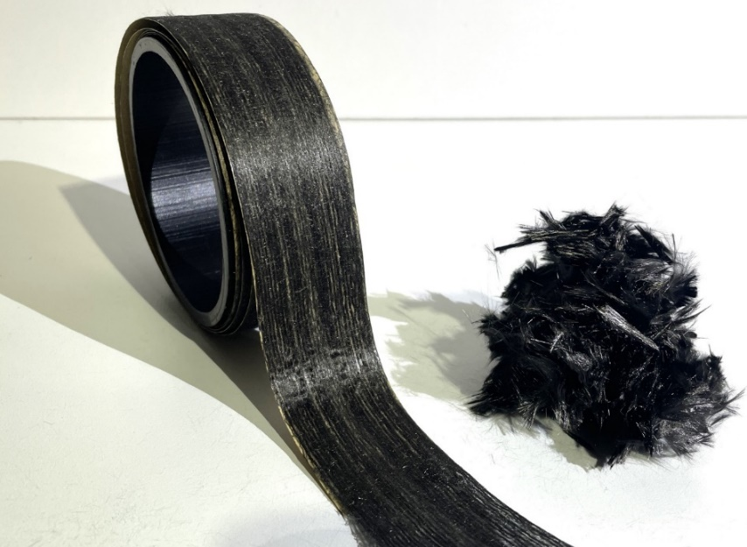

Aligned fibre tape and reclaimed fibres (Ref: Lineat Composites)

Modern engineered composites are made with synthetic fibres, produced as endless continuous yarns. This well-controlled process produces high strength fibres but complicates composite production as the inextensible nature of the fibres makes them hard to form to shape. Process waste is typically 30% and over 90% of carbon fibre ends up in landfill. Current reclaimed carbon formats are either random mat or very short, milled fibres.

Lineat’s Aligned Formable Fibre Technology (AFFTTM) produces an entirely new feedstock format by taking chopped fibres, recovered from End of Life or process waste. AFFT effectively aligns them into a uni-directional tape. This allows 80% property retention with the added benefit that the fibres can move relative to each other during forming operations. Extensional strains of up to 20% are possible, so mimicking metals in stamp-forming type processes. Full carbon fibre circularity has already been demonstrated with the recovery of carbon fibres from an old tennis racket, followed by re-alignment and re-manufacture of a new tennis racket.

The Lineat team is now working with UK advanced manufacturers to find the best ways to convert the aligned fibre tapes into product and produce lightweight composites, maximizing the sustainability and formability benefits. Their goal is to make more out of carbon, which requires aligning both fibres and people to adapt to this new material.

Estimated time to maturity: 2 years
Source: Lineat Composites / www.lineat.co.uk
Thermoplastic composite applications feature strongly in JEC Composites Innovation Awards for 2025

Thermoplastic materials and associated applications featured strongly in the shortlist and eventual category winners in JEC composites yearly innovation award, highlighting the technologies unique combination of attributes.

The prevalence of thermoplastic applications short listed, across a wide variety of industries, demonstrates the increasing interest and exploitation of thermoplastic composites in end user applications. The materials combination of high mechanical performance, good impact damage tolerance, rapid processability, plus improved recyclability and sustainability attributes, highlights the importance of this class of material in the next generation of engineering applications. Thermoplastics and other sustainable materials featured strongly in the winning submissions across the majority of the award categories, with many more of the shortlisted submissions also utilising similarly sustainable approaches to engineering applications.

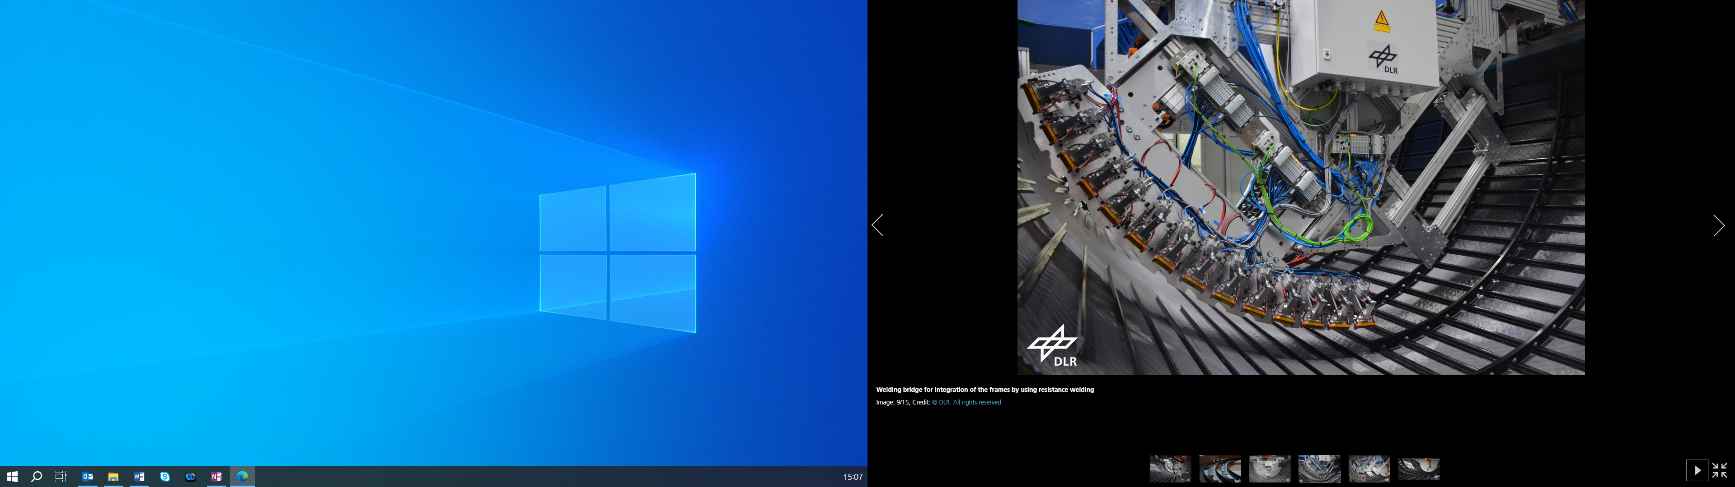

Welding bridge for integration of the thermoplastic frames using resistance welding within the Multifunctional Fuselage Demonstrator
Source: https://www.dlr.de/ © DLR. All rights reserved

The winning submission in the Aerospace Parts category was The Multifunctional Fuselage Demonstrator, delivered from a CleanSky2 programme involving a consortium of 12 organisations led by Airbus (Germany) (source: JEC Composites). The 8m x 4m demonstrator is based on a typical single commercial aircraft fuselage manufactured from thermoplastic composites including novel part manufacturing techniques and a thermoplastic resistance welding assembly approach.

Estimated time to maturity: 2 -5 years
Source: JEC Composites Innovation Awards 2025: Discover The 11 Winners
- Project Showcase: MAXBlade and CoTide: Renewable Tidal energy in the UK
James R. Davidson^{1,2}, Danijela Stankovic Davidson¹, Tala Abbasian^{1,2}, Colin Robert¹
¹ School of Chemical, Material and Biological Engineering, Faculty of Engineering, University of Sheffield, UK
² Advanced Manufacturing Research Centre, University of Sheffield, UK

Tidal Energy and Research in the UK
Guest writer: Dr James R. Davidson

The UK is at the forefront of tidal energy innovation, focusing on advanced composite materials and specialised testing to boost the durability and efficiency of tidal turbine blades. Through its Contracts for Difference (CfD) scheme, the government recently provided revenue support to 50 MW of tidal projects, emphasizing tidal energy as a vital low-carbon resource. Researchers are developing recyclable thermoplastic composites to tackle the harsh marine environment, offering improved fatigue and corrosion resistance. This aligns with the UK’s circular economy goals by reducing waste and potentially lowering long-term costs in tidal energy projects.

To rigorously test these materials, the UK has invested in advanced facilities. The European Marine Energy Centre (EMEC) in Orkney provides real-world marine conditions for evaluating turbine prototypes, allowing developers to monitor and assess the performance and structural integrity of blades under operational stresses. Additionally, the FastBlade facility at the University of Edinburgh represents a breakthrough in accelerated fatigue testing. FastBlade utilises hydraulic actuators to apply high-cycle fatigue loading conditions, simulating decades of stress on turbine blades within just a few weeks. This facility is the first of its kind tailored specifically to the high-cycle fatigue testing requirements of tidal and wind turbine blades, making it an essential resource for verifying blade durability before field deployment.

These facilities are supported by the UK’s advanced research ecosystem, including the Advanced Manufacturing Research Centre (AMRC) and several leading universities, which contribute expertise in material science, structural engineering, and computational modelling. Research efforts at these institutions are advancing the understanding of material behaviour under tidal conditions, optimizing blade designs for longevity and resilience. Computational modelling techniques enable researchers to predict blade performance over time, guiding design improvements to address issues like leading-edge erosion and structural fatigue.
These emerging technologies present promising advantages for coastal countries, like the UK, in achieving reliable, sustainable energy production while reducing reliance on fossil fuels.

MAXBlade: The Future of Tidal Turbine Blade Design
Guest writer: Dr Danijela Stankovic Davidson

Orbital Marine Power’s O2 tidal turbine represents a significant leap in marine renewable energy, harnessing cutting-edge technology to deliver a cleaner, more sustainable power source. Orbital’s unique floating platform presents a radical break from previous generations of tidal turbines along with a pioneering new approach to installing and maintaining offshore renewable technologies. The turbine sits on the surface of the water with rotors below, harnessing the power of the water rushing by upper parts of the water column, where tidal currents are fastest. Furthermore, an on-board hydraulic retraction system lifts the legs to the surface to provide easy access to all major components. With 20-meter rotor diameters, advanced blade pitch control, and a robust four-point mooring system, Orbital’s innovation exemplifies the commitment to reducing dependency on fossil fuels and contributes to climate change mitigation, air quality improvements, and the global energy transition.

Complementing Orbital’s advancements, the MAXBlade project, funded by the European Union and UKRI, is set to revolutionise tidal energy with commercial relevance by developing and delivering optimised tidal turbine blades. Aiming to increase rotor diameters from 20 meters to an impressive 26 meters, MAXBlade will expand the swept area by 70%, significantly boosting energy capture and efficiency. This project also emphasises sustainability through circularity, using recyclable thermoplastics for blade production, ultimately enhancing the cost-effectiveness and longevity of tidal turbines. By 2030, MAXBlade’s innovations will support European leadership in tidal energy, with a planned capacity to produce 320 tidal blades annually. Together, Orbital Marine Power and MAXBlade are shaping a resilient, efficient, and sustainable future for tidal energy, ensuring that Europe remains at the forefront of marine renewable technology.



Figure 1: Orbital 2 Launch Promotional Photo

CoTide: Pioneering Sustainable Tidal Energy

Guest writer: Mrs. Tala Abbasian

The CoTide project is set to revolutionise tidal Stream Energy generation by developing integrated tools and design processes to reduce costs and enhance engineering confidence. By 2030-40, it aims to make tidal energy a key player in climate change mitigation. The project focuses on three themes: System Performance, Scalability, and Sustainability.

Funded by the EPSRC, CoTide brings together the expertise of the University of Oxford, the University of Edinburgh, the University of Strathclyde, the University of Sheffield, and the Advanced Manufacturing Research Centre (AMRC). Using a coordinated approach called control co-design (CCD), CoTide disrupts traditional engineering processes to create innovative solutions, considering the entire system from the start.
Key research areas include understanding environmental impacts on turbines, optimising blade durability, and integrating site characteristics into designs. The project will also develop new certification pathways to ensure high quality and reliability.

One of the major focuses of the project is advancing the design and performance of tidal blades. The goal is to improve the performance and durability of composite blades by exploring how different materials, structural designs, and manufacturing processes impact them. The team will also investigate the use of thermoplastic and bio-based materials to make the manufacturing process more sustainable and the blades easier to recycle. Notably, the blades will incorporate recycled materials in their structure and will be fully recyclable at the end of their life, supporting a circular economy. Innovative manufacturing methods, such as 3D printing with recycled thermoplastic pellets, will be explored to enhance sustainability and efficiency.

The project will conduct thorough tests to verify their design methods and set the stage for certifying these advanced composite blades and rotors. This includes tasks such as manufacturing sustainable blades, designing robust blade-hub connectors, and testing the fatigue performance of composite blades. They will also address the issue of leading-edge erosion to ensure the blades can withstand the harsh ocean environment.

By using advanced simulation methods and high-quality manufacturing and testing facilities, the project aims to optimise blade design for maximum performance and longevity. CoTide is about pushing the boundaries of tidal energy technology and contributing to a more sustainable future.

Funding acknowledgements:
MAXBLADE: EU Union and UKRI https://cordis.europa.eu/project/id/101096891
More information on https://maxblade.tech/

CoTide: EPSRC grant reference EP/X03903X/1
More information on https://cotide.ac.uk/

- Materials Metrology Technology: New developments in thermal conductivity measurements- InoTherm®
Oleksii Popov¹, Sajad Haq², and Vladimir Vishnyakov¹
1) Inomorph Ltd, Huddersfield, HD1 3BD, UK
2) QinetiQ, Farnborough, GU14 0LX, UK
Thermal conductivity manifests the transfer of thermal energy, usually referred to as heat, through matter when there is a temperature difference in the surroundings. Knowledge of heat transfer is crucial in many applications. It should be stressed that heat conductivity through engineering items or structures can only be accurately predicted if the thermal conductivity coefficient is measured at conditions closely reproducing the application conditions in all aspects. By their nature, materials represent a considerable challenge for accurate thermal conductivity measurements as the most widely available measuring methods and models rely on the “simplifying” assumption that the materials are homogeneous and isotropic. Even if the assumption is well grounded, the thorough mathematical heat transfer analysis is quite complex. Hence there are significant issues when measuring the properties of structured and composite materials, such as fibre composites where there is, for example anisotropy, and significant variation in microstructure, such as fibre orientation, in two or three dimensions.
Contemporary instruments available for acquisition are based on methods and ideas developed in the past, but a new set of instruments uses available computing power for collecting, processing, and modelling experimental data. Unfortunately, in some cases, the convenience of acquiring thermal conductivity values rapidly leads to the unquestionable use of measurement solutions and often produces inaccurate or erroneous results.
Heat propagation through material is very complex. The fundamental assumption for heat propagation is that the material is isotropic and homogeneous but modern materials are based on micro- and nano-sized complex structures like spatial element segregations, defects, voids, and grain boundaries within the material and composites with inherent multiphase structures. These structures enhance the engineering properties and enable tailoring for specific applications. The more advanced materials we have - the more complex chemistries and structures underpin them. As we strive for property optimisation, the number of combinations and trial samples grows. We need fast, convenient, and accurate analytical tools to characterise the materials we develop.
The above creates one set of challenges for measuring thermal conductivity. Another set of questions is related to the sample geometry, morphology and format available for measurements. Historically, thermal conductivity was measured almost exclusively for bulk materials. Materials were in abundance, cheap and large, and consequently sample preparation for the analysis was relatively easy. However modern materials such as thin films and complex tailored materials, need to account for previously neglected issues such as sample cost, and preparation difficulties, and fibre reinforced composite materials and structures will have properties depending on the orientation of the fibres. This is further exacerbated by the interfaces between materials that will influence the transport of heat.
Many instruments on the market promise to cater to broad spectra of materials and sample sizes in one implementation. As materials and available sample geometries vary widely, some instruments and measuring methods are better suited to producing more accurate data faster and for less expense. Available computing power, coupled with the capability to dynamically accumulate temperature measurements from many points, recently enabled the development of the so-called ‘Quasi-steady-state approach’ to measuring the coefficient of thermal conductivity.
The primary method is as follows. The investigated sample is clamped between the heat source and heat sink surfaces. The contact interfaces are improved with a thermal interface material for highly conductive materials to minimise the contact thermal resistance. The heat flows from the heat source through the sample to the thermostat. The thermostat heat capacity is known, and a rising thermostat temperature allows the calculation of the amount of heat transferred. When the heat flux through the sample equals the heat flow from the heater, the temperature difference across the sample is stable. The thermal losses from the thermostat can be evaluated experimentally and accounted for. The experiment lasts a few minutes.
The above approach is realised in the InoTherm® measuring system (www.inomorph.co.uk). The instrument is shown in Fig. 1. It is possible to measure small amount of liquids, for instance Fig. 2 shows droplet of water prior to measurement in the InoTherm liquid cell.
The InoTherm® system and the quasi-steady-state measurement method has been validated through rigorous testing and inter-comparisons of a range of materials. Careful calibration and assessment show that the maximum measurement uncertainties (Δk/k) of InoTherm® depend on material thermal conductivity: 5% for k = 0.05 ÷ 1 W/m·K; 4% for k = 1 ÷ 5 W/m·K; 2% for k = 10 ÷ 90 W/m·K; 4% for k = 100 ÷ 200 W/m·K, and 5% for k = 250 ÷ 500 W/m·K.
This new instrument allows for cost-effective and time-saving measurement of the thermal conductivity coefficient of a broad range of materials. Small samples, down to 0.1 cm3, can be measured, reducing material and sample preparation expenses. The method is direct and does not rely on other data to produce thermal conductivity coefficient values. In combination with the InoTherm® measuring system it is possible to utilise modelling techniques to evaluate the orientation dependent thermal behaviour of materials. The system has the flexibility to measure materials in alternative geometries and orientations, due to its novel design features.
Table 1 contains values measured by InoTherm and widely accepted values for the measured materials are provided. It is possible to see that the instrument measures thermal conductivity from hundreds W/mK (Copper) down to below 1 W/mK (Water). Homogeneous materials (copper, aluminium, tungsten) can be measured and the data for fibre reinforced composites can also be successfully obtained.
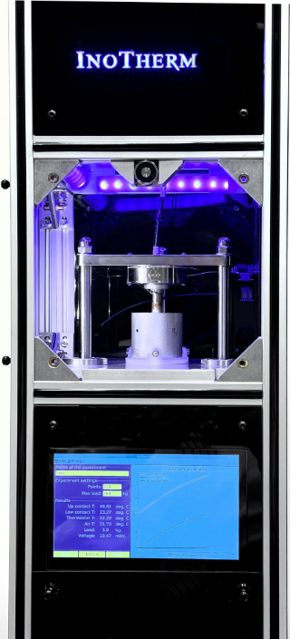 | 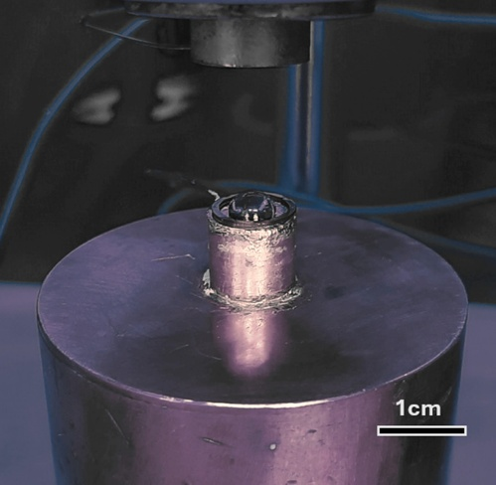
Fig. 1. InoTherm® general view | Fig. 2. Water droplet prior to measurement

Material | Density ρ (g/cm³) | Relative density  ρ (%) | k_{exp} (W/mK) | Δk, (W/mK) | k_{ref}, (W/mK) | Sample volume (cm³)
Copper bulk | 8.96 | 100 | 393 | 10 | 397 | 0.7
Copper foil  (0.3 mm) | 8.96 | 100 | 395 | 15 | 397 | 0.2
Tungsten | 18.35 | 95 | 146 | 3 | 146 | 0.5
Aluminium foil (0.008 mm) | 2.7 | 100 | 223 | 5 | 238 (for bulk Al) | 0.1
PTFE | 2.2 | 100 | 0.29 | 0.01 | 0.3 | 0.1
Plywood | 0.5 | N/A | 0.13 | 0.01 | 0.11 ÷ 0.15 | 0.1
Cork + resin composite | 0.52 | N/A | 0.28 | 0.01 | N/A | 0.1
ZrB2 | 6.09 | 100 | N/A | N/A | 83.8 | N/A
Graphite | 1.84 | 84 | 160 | 2 | 160 | 0.5
ZrB2 – Graphite composite | 4.96 | 97 | 40.9 | 0.8 | N/A | 0.5
RS-Pro Thermal grease | - | 100 | 2.64 | 0.1 | 2.7 | 0.1
Table 1. Thermal conductivity coefficient as measured by InoTherm® instrument in comparison with known values.
K_{exp} – value measured by InoTherm
Δk – measurement error
K_{ref} – ubiquitous value taken from the engineering tables and published papers.

- Funding opportunities

APCUK: Advanced Route to Market Demonstrator 4 (ARMD4)
UK registered businesses can apply for a share of up to £25 million for late stage research and development projects that help accelerate the UK transition to zero emission vehicles and towards a net zero automotive future.
More details here: https://www.ukri.org/opportunity/apc-advanced-route-to-market-demonstrator-4-armd4/

APC26: industrialising net zero automotive technology
UK registered businesses can apply for a share of up to £40 million for late stage research and development projects. These projects will help accelerate the UK transition to zero emission vehicles and towards a net zero automotive future.
More details here: APC26: industrialising net zero automotive technology – UKRI

Pre-announcement: Funding for the Commercialisation of Research
Apply for proof of concept funding to support the commercialisation of research to enable spinouts or social ventures, licencing or other commercialisation pathways. Applications from any disciplines are welcomed. This is a pre-announcement, and the information may change. The full funding opportunity will open on 12 March 2025.
More details here: Pre-announcement: Proof of Concept – UKRI

ATI Funding Opportunities
The ATI has published its latest dates and deadlines for competitions and submissions.
More details here: ATI-Programme-Competition-Dates-2025
All proposal submissions must be aligned with the UK aerospace technology strategy “Destination Zero” which can be downloaded here. Destination Zero identifies 4 priority areas for consideration:

- Zero-carbon emission aircraft technologies
- Ultra-efficient aircraft technologies
- Cross-cutting enablers
- On-CO2 technologies.

